March 9, 2015

Standing Room Only for
Heaven Really is For Real
a Lunchtime Talk by Bro. John Maganzini, OFM

Twenty parents attended the first-ever Brown Bag Lunch Retreat of the Emmaus Ministry for Grieving Parents at St. Anthony shrine & Minsitry Center on Monday, March 9 from 12:15pm-1:15pm. They came to hear Bro. John Maganzini’s wonderful message of hope and comfort that Heaven Really is For Real.
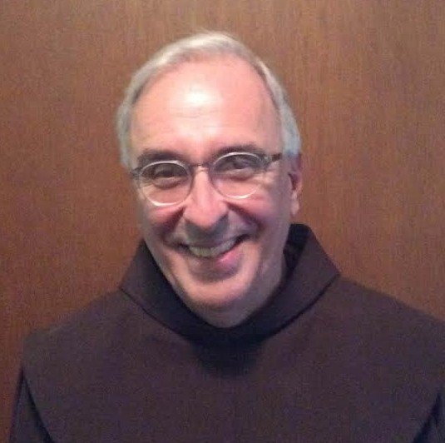
Over and over again, Bro. John emphasized the fact that the memory of a child is really the presence of the child because the bond of love is never broken and our children are with us constantly. Instead of saying, “In Loving Memory Of…,” we should say, “In the Loving Presence Of....”

Our children are part of the Communion of Saints in heaven, he reiterated —and they are actively with us—every day. In the Creed, we restate our belief in the Communion of Saints, the Resurrection of the Body, and in Life everlasting. “Only a veil separates heaven and earth,” he said, “Your children are very much alive and with you right now.”

Just as Jesus joined his friends on the walk to Emmaus, we are on a journey of grief. But, along this journey we have help… a team of supporters: Jesus on one arm; Mary on the other arm; and our child gently pushing us from behind.

Our child is with us on this journey gently pushing us from behind, just as we “pushed” him or her as parents, helping them along their journey of life.

Again, Bro. John stated that the bonds of love are never broken. When we get to heaven,
everyone we have ever loved—and who has loved us—will be there to join us, gathering together in a wondrous, joyous reunion. There will be no more tears, just joy and love.

There is a light deep inside of each of us, said Bro. John. This is the Holy Spirit, at some times brighter than at others, but always there. If we look further, we see inside of ourselves a special space, into which we invite the Holy Spirit to nourish us… to give us strength, hope, and love.

Keeping focused on the spirituality of the grieving process can give us strength and something definite to hold onto when we are in despair. As the psalmist in Psalm 129 cried, “Out of the depths I cry to you, O Lord… Lord, hear my voice! Let your ears be attentive to my voice in prayer!”

We are all “poor in spirit” meaning we can’t do it alone. Every morning when his feet touch the floor, Bro. John reminds God that he ( Bro. John) is poor in spirit and needs help getting through the day.

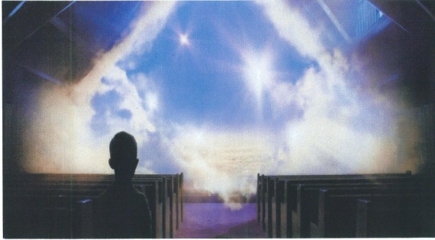
In addition to the image of Jesus walking with us on our grief journey, the other central theme of the Emmaus Ministry is Light… Light signifying the presence of God, the presence of our our children, and the presence of our Love. It is in the “lighting of the light” that we find the Holy Spirit.

Bro. John then read this prayer:
On the other side of darkness, far way there shines a light,
A light to end all sorrow,
A light that is ever free,
A light for a new tomorrow
A light for you and me.
Amen.

With total confidence, solid conviction, and unfaltering belief, Bro. John quoted a popular song by Carrie Underwood…“I will see you again; this is not where it ends. I will carry you with me ‘til I see you again.”

Other quotes in his materials included…
“Those we love can never be more than a thought away… for as long as there’s a memory, they live in our hearts to stay.

“Our departed loved ones will always be our assigned angels watching over us.”
“Those we love don’t go away; they walk beside us every day…Unseen, unheard, but always near… Still loved, still missed and very dear.”

Bro. John then concluded his amazing talk with the poem, “On the Death of a Beloved,” which ended with the comforting words….
“Until we see your beautiful face again
In that land where there is no more separation
Where all tears will be wiped from our mind
And where we will never lose you again.”

Here is the poem in its entirety:
On the Death of a Beloved
Though we need to weep your loss,
You dwell in that safe place in our hearts
Where no storm or night or pain can reach you.

Your love was like the dawn
Brightening over our lives,
Awakening beneath the dark,
A further adventure of color.

The sound of your voice
Found for us
A new music
That brightened everything.

Whatever you enfolded in your gaze
Quickened in the joy of its being:
You placed smiles like flowers
On the altar of the heart.
Your mind always sparkled
With wonder at things.

Though your days here were brief,
Your spirit was alive, awake, complete.
We look toward each other no longer
From the old distance of our names;
Now you dwell inside the rhythm of breath
As close to us as we are to ourselves.

Though we cannot see you with outward eyes,
We know our soul’s gaze is upon your face,
Smiling back at us from within everything.
To which we bring our best refinement.

Let us not look for you only in memory,
Were we would grow lonely without you.
You would want us to find you in presence,
Beside us when beauty brightens,
When kindness glows
And music echoes eternal tones.

When orchids brighten the earth,
Darkest winter has turned to spring;
May this dark grief flower with hope
In every heart that loves you.

May you continue to inspire us, to enter each day with a generous heart.
To serve the call of courage and love,
Until we see your beautiful face again
In that land where there is no more separation,
Where all tears will be wiped from our mind,
And where we will never lose you again.
(from To Bless the Space Between Us, John O’Donohue)

After the presentation, parents enthusiastically thanked Bro. John. “Phenomenal,” said one. “So good,” said another, “this is what we need to hear over and over again.” “We’ll be back,” said yet another.

“It was a day to remember for me...a day of blessing...each time I share that talk, my faith and spiritual life grows stronger,” said Bro. John.

The Emmaus Ministry for Grieving Parents at St. Anthony Shrine will be offering its next Brown Bag Lunch Retreat on Monday, March 16, 2015 from 12:15pm-1:15pm. Peggy Hassett, the ministry’s spiritual director, will share “Finding God Again After a Sudden, Violent Loss.”

Concluding the ministry’s Lenten programs will be a One-Day Spiritual Retreat on Saturday, March 21. For more information or to register, go to www.emfgp.org or call Diane, Mother of Paul, at 617-542-8057.

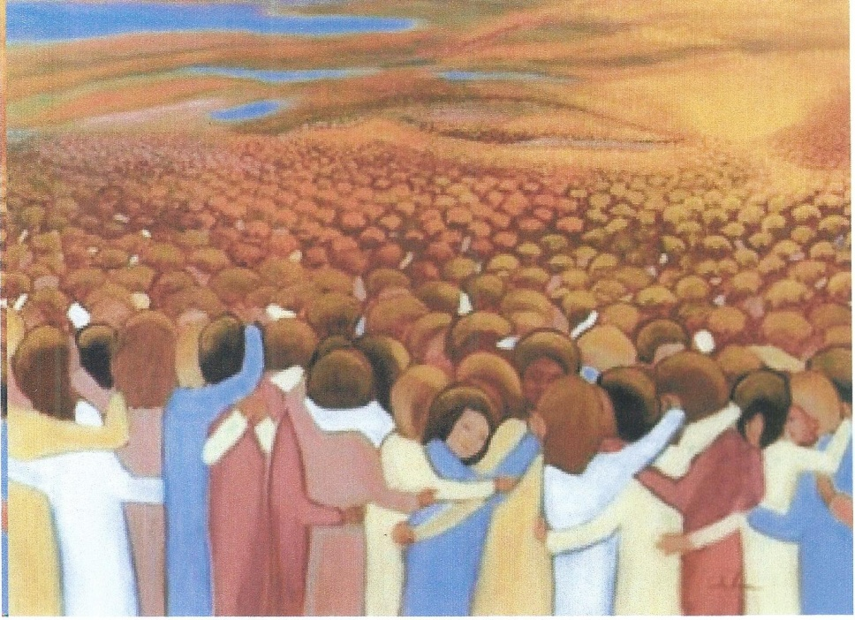
The Communion of Saints

