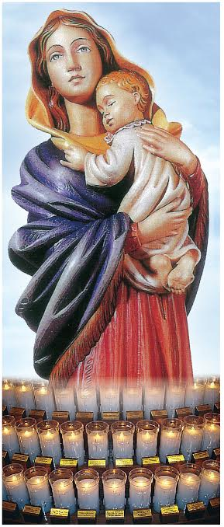

Mary, Mother of God Candles
St. Anthony Shrine

□ I choose not to renew my Mary, Mother of God candle at St. Anthony Shrine for next year.

- Please renew my Mary, Mother of God candle at St. Anthony Shrine, and ask the friars to continue to pray for the following loved ones (Please print.):

- ________________________________________________________________________________________@$300

- ________________________________________________________________________________________@$300

- ________________________________________________________________________________________@$300

TOTAL $________________
Please complete this form and return it to:
Ariana Green
St. Anthony Shrine
100 Arch Street
Boston MA 02110

[ ] Enclosed is my check. [ ] Please charge my credit card.

[ ] MasterCard [ ] Visa [ ] Discover [ ] American Express

Credit Card Number: __________________________________________ Expiration Date: _____ _

Name: ___________________________ ____________________________________________________________

Address: __________________________________________________________________________________ ________

Email: _________________________________Phone: ______________________ ____________________________

Please Note: We have a waiting list for Mary, Mother of God candles. To ensure renewal of your candle, please submit this form and your gift of $300.. Call Ariana at
857-206-7243, if you have questions. Thank you.

